**Practical Assignment**

**Objective: - Visual Question Answering**

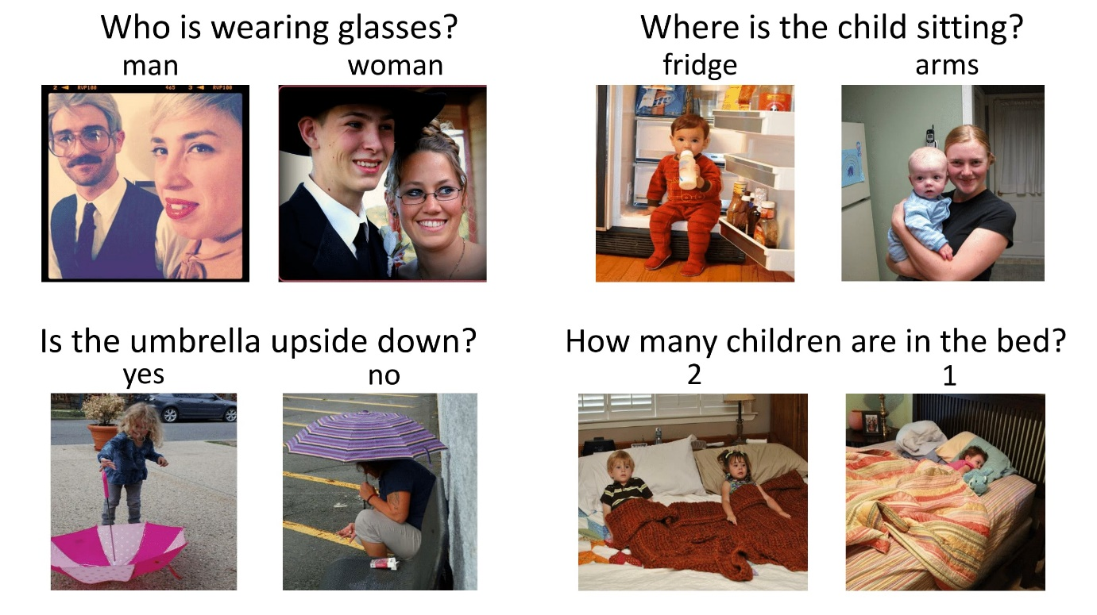

**Dataset Link: -**

[**https://visualqa.org/vqa_v1_download.html**](https://visualqa.org/vqa_v1_download.html)

**Task: -** Create a Web Application using Flask. Use the end user should be able to upload an image and ask questions and get the answers.

**Deployment: -** Any Free Platform(Try to look out for free options.)

**Assignment Submission: -** Only submit the hosted app link. OR GitHub Link